

**Calculus Tasks**

Student Name : Ahmed Ashraf Ali Sayed

Date : 15/2/2021

**GitOps** : An operating model for building cloud native applications GitOps can be summarized as these two things: An operating model for Kubernetes and other cloud native technologies, providing a set of best practices that unify Git deployment, management and monitoring for containerized clusters and applications. A path towards a developer experience for managing applications; where end-to-end CICD pipelines and Git workflows are applied to both operations, and development and its principal is to start managing your cluster with GitOps workflows, the following must be in place

**The 7Vs of Big Data**: Volume, Velocity, Variety, Variability, Veracity, Value, and Visibility.

**Big data tools**

1. Apache Storm.
2. MongoDB.
3. Cassandra.
4. Cloudera.
5. OpenRefine

**Gradeint descent proof:**before we dive into gradient descent, it may help to review some concepts from linear regression. You may recall the following formula for the slope of a line, which is y = mx + b, where *m* represents the slope and *b* is the intercept on the y-axis.You may also recall plotting a scatterplot in statistics and finding the line of best fit, which required calculating the error between the actual output and the predicted output (y-hat) using the mean squared error formula. The gradient descent algorithm behaves similarly, but it is based on a convex function, such as the one below:

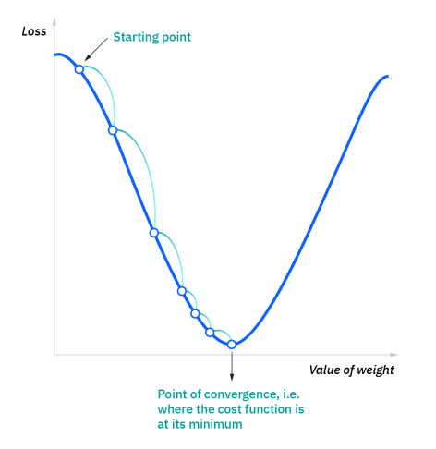

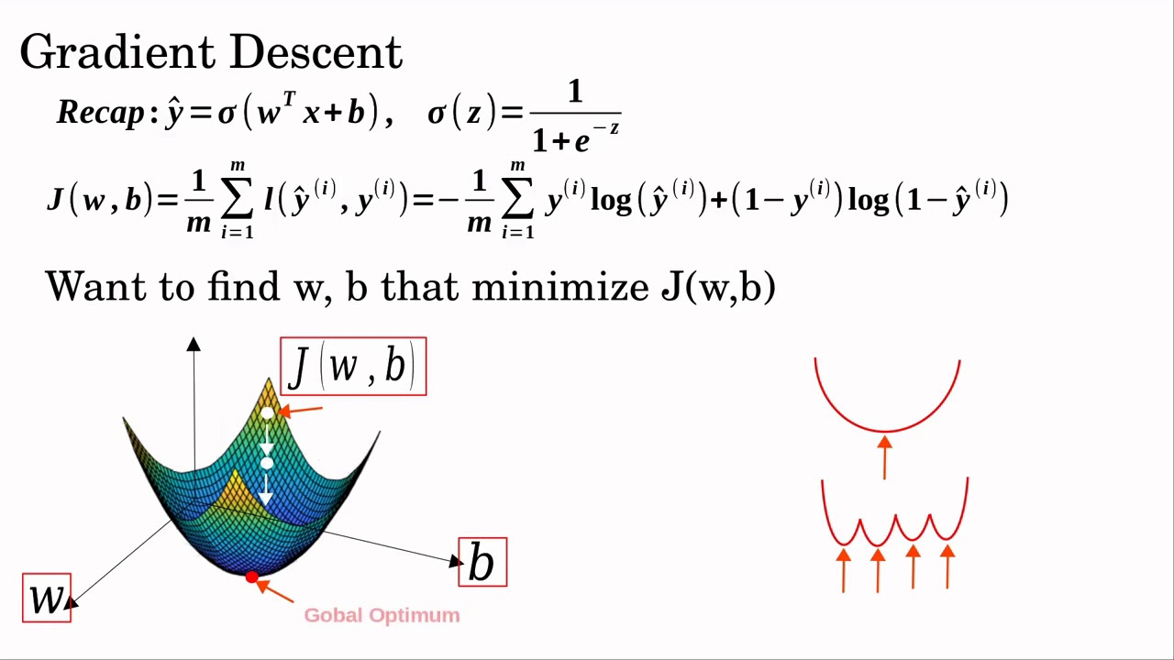

**What is the meaning of overfitting?**

Overfitting happens when a model learns the detail and noise in the training data to the extent that it negatively impacts the performance of the model on new data

**What is the different between relational and non-relational database**

Relational Database : Tables are structured related to each other Each specific type of domain data is strored it's own table

Non-Relational Database : There is no relation at all between tables Mostly key+value.

**Genetic algorithm** is a method of optimization and research.This method can be classified as one of the methods of evolutionary algorithms that relies on imitating the work of nature from a Darwinian perspective.the genetic algorithm uses a search technique to find exact or approximate optimal solutions. Genetic algorithms are classified as a comprehensive heuristic search method. It is also a specific class of evolutionary algorithms also known as evolutionary computation that uses technology inspired by evolutionary biology such as inheritance, mutation, selection and crossbreeding. genetic algorithms are considered one of the important techniques in the search for the optimal choice from a set of solutions available for a particular design, and adopt Darwin’s principle of selection, where this genetic treatment passes the optimal advantages through successive reproductive processes, and strengthens these traits, and these traits have the greatest ability to enter the reproductive process By repeating the genetic cycle, the quality of the offspring gradually improves.

**Why we use integration in AI?**

using integration provides a way to compute the area under the curve of almost any function. There are many applications for integration. For example, if you need to compute a probability of some occurrence between limits (which we'll discuss later in this course), then you will use an integral

**Data visualization** techniques are visual elements (like a line graph, bar chart, pie chart, etc.) that are used to represent information and data

**linearization** : You can convert the nonlinear function to the linear form by using Taylor expansion around a certain chosen point under the condition that the nonlinear function is continuous and possing partial derivatives up to the second order around this point. the nonlinear model can be approximated by a linear model. This is called linearization

